User Guide

## Installation Instruction:

* Active Internet Connection.
* Download and Install Greenfoot on your machine:
  + [Windows Download Link](http://www.greenfoot.org/download/files/Greenfoot-windows-304.msi)
  + [Mac OS Download Link](http://www.greenfoot.org/download/files/Greenfoot-mac-304.zip)
  + [Ubuntu Download Link](http://www.greenfoot.org/download/files/Greenfoot-linux-304.deb)
* Download and install latest version of Java
  + [Visit Page to Download Java](http://www.oracle.com/technetwork/java/javase/downloads/jdk8-downloads-2133151.html)

## Download Game from our Github Repository:

* Visit **URL**: [Github Repo Link for Game Download](https://github.com/carlo379/Magicians).
* Use Code in “Final Version with User Guide” Folder.

## Play Game:

### Open game:

* Go to Game Client folder, and click *project.greenfoot* file.
* Game opens with animation introduction, and it will land on *Menu* section.
* Two buttons – *Play* and *Theory* will be displayed on *Menu*.

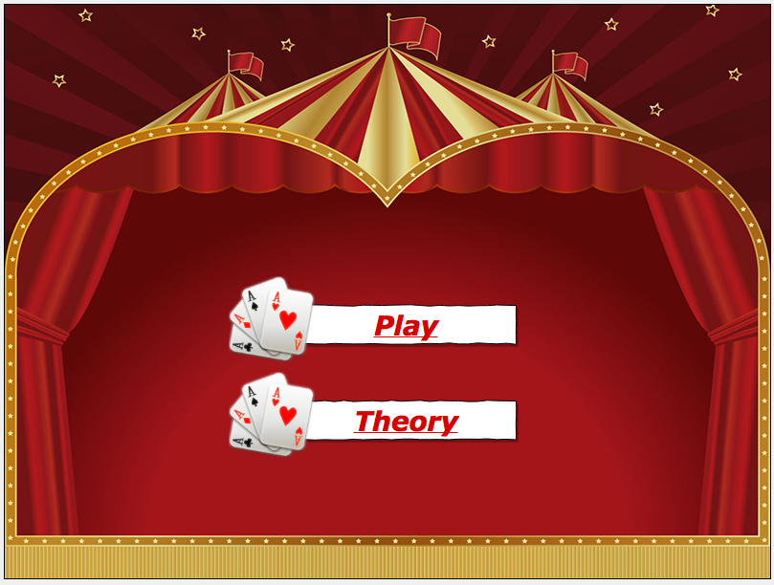

1. Start game:

* Click the *Play* button , a window pops up for entering player’s name

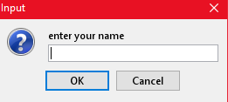

* Enter the name,
  + If no player joined game, waiting message will be showed on the screen

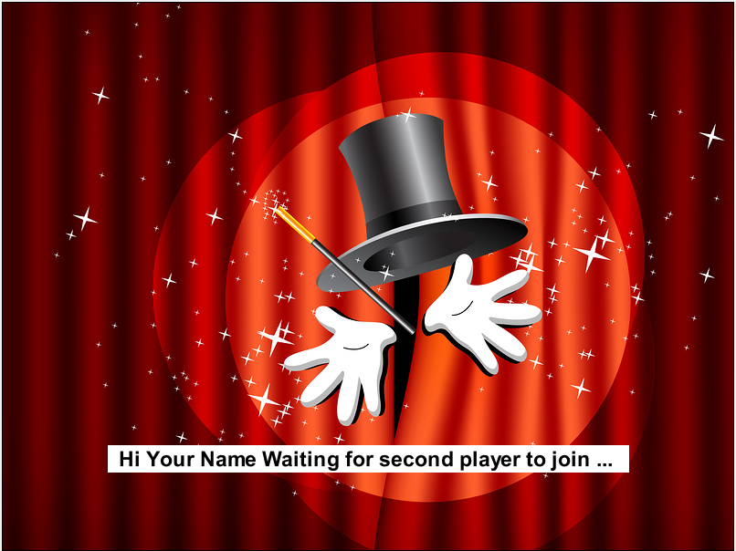

* + Otherwise, screen will display the play stage with 5 x 5 grid of cards
* When another player starts the game, screen changes to player world.

### Play game:

* Instruction message shows on top of the windows.
* Additional cards are added to the grid, the curtain covers the stage, and soon *Timer* and *Rocket* button C:\Users\RS\AppData\Local\Microsoft\Windows\INetCache\Content.Word\rocket.pngshow on stage.
* Click the card you think is flipped.

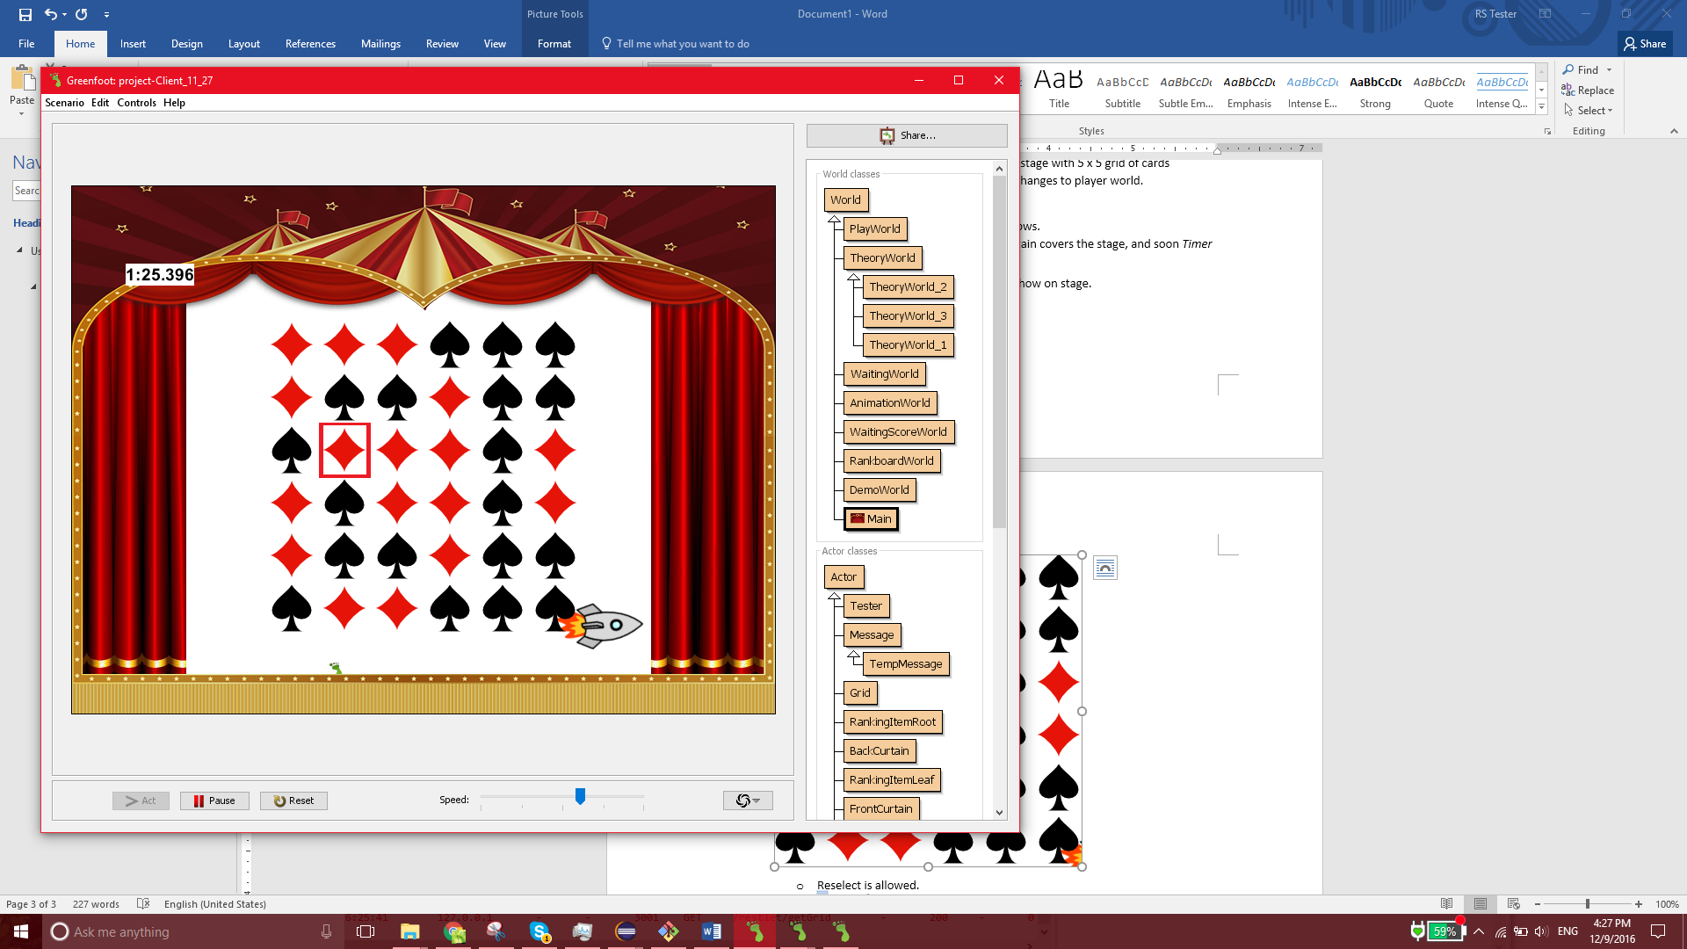

* + Reselect is allowed.
* Click Rocket C:\Users\RS\AppData\Local\Microsoft\Windows\INetCache\Content.Word\rocket.pngto confirm your selection.
* Correct card will be circled after your submission.

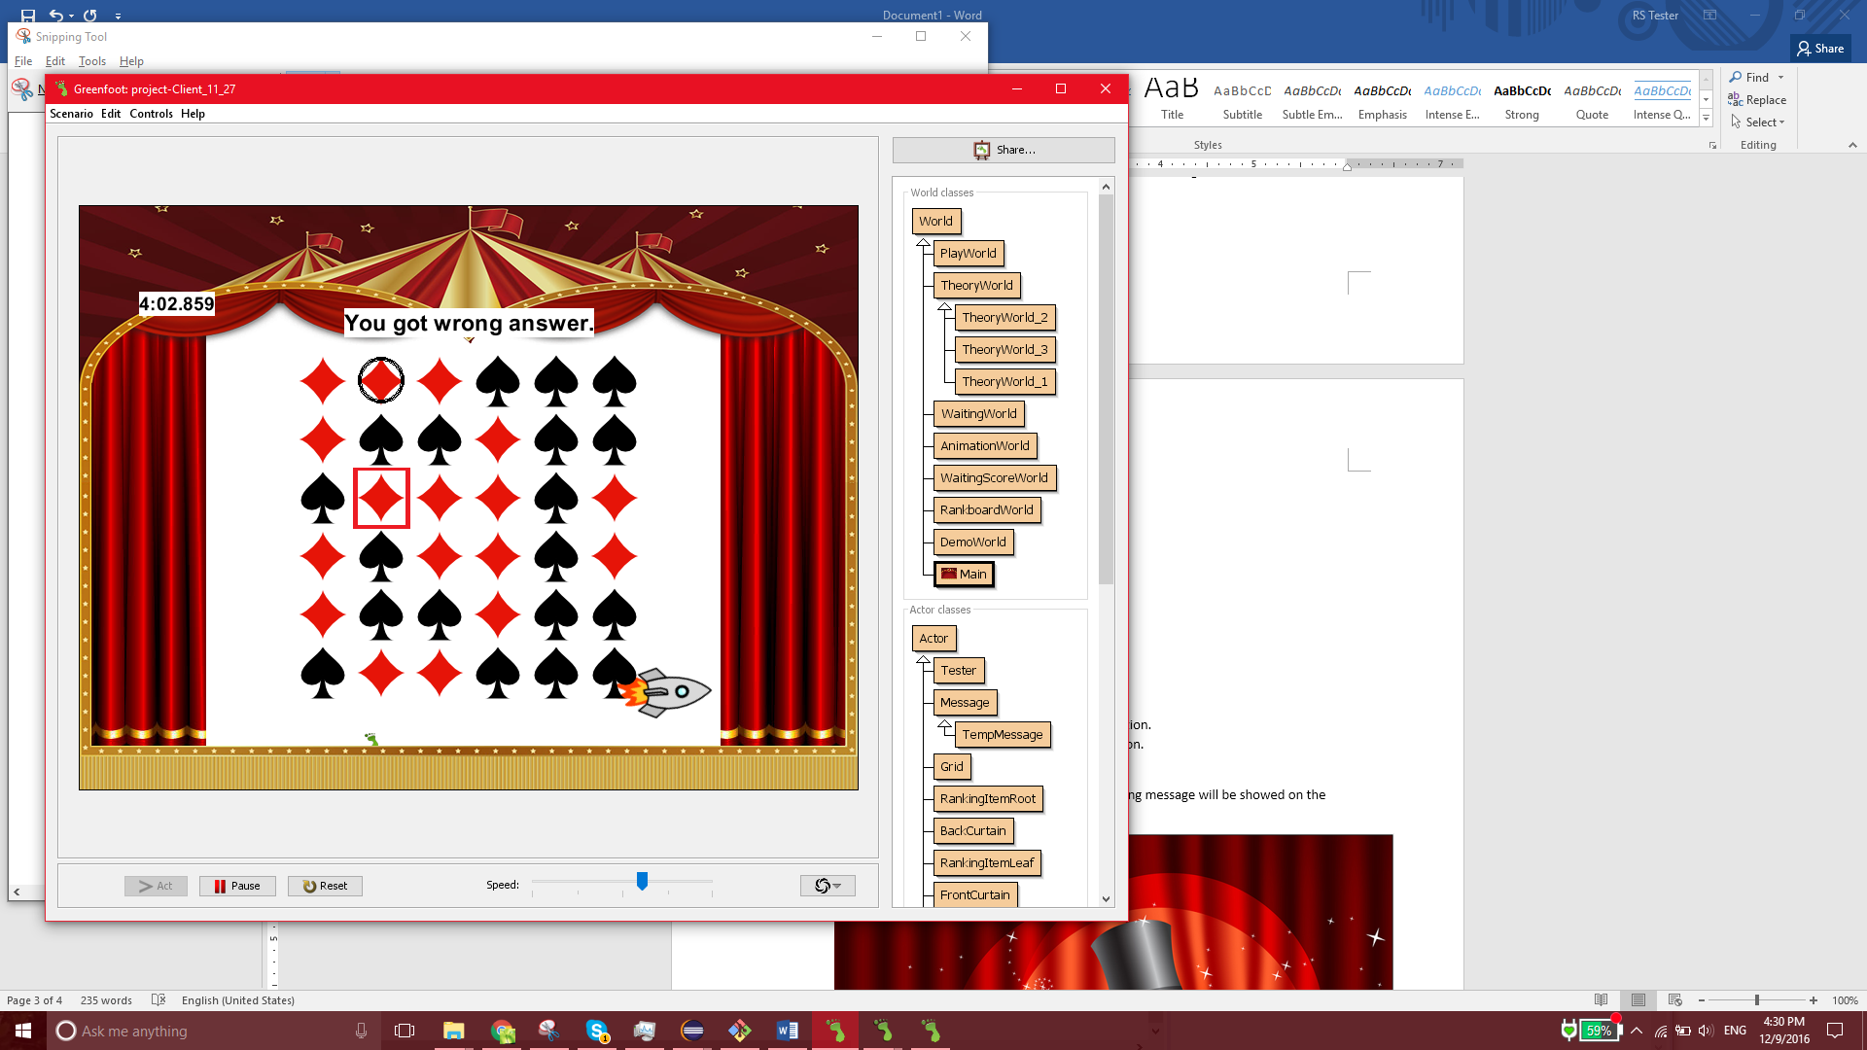

### View game result:

* If another player is still playing the game, waiting message will be showed on the screen.

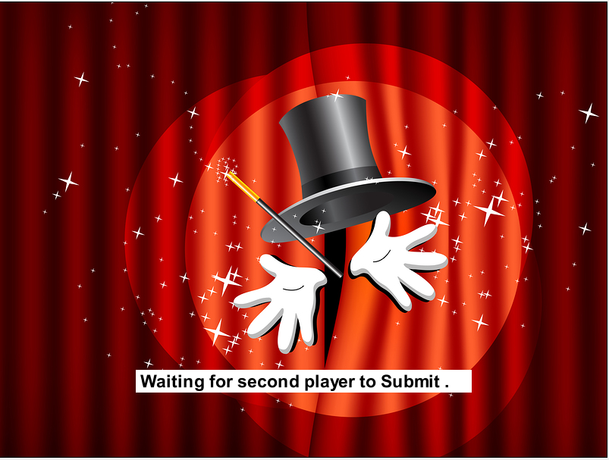

* Otherwise, game result displayed on screen.

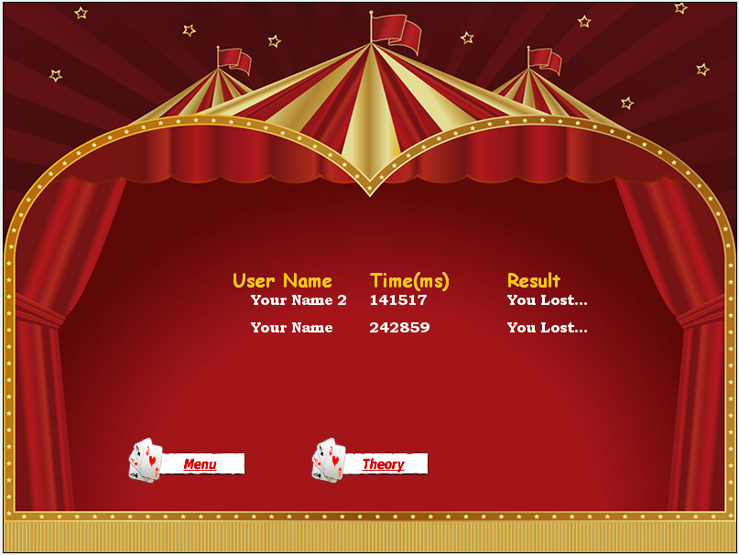

* Click *Menu* button **to go back to *Menu.*

## Learn Theory Behind Game:

* Click *Theory* button on *Menu*, navigate to *Theory* section.
* Click Next button C:\Users\RS\AppData\Local\Microsoft\Windows\INetCache\Content.Word\rightarrow.pngon Theory section to go through the trick of the game and the concept of the computer science.
* Click *Menu* button **to go back to *Menu.*